**Project Design Phase-I**

**Solution Architecture**

|  |  |
| --- | --- |
| Date | 06 NOVEMBER 2022 |
| Team ID | PNT2022TMID22240 |
| Project Name | SMART SOLUTION FOR RAILWAYS |
| Maximum Marks | 4 Marks |

**Solution Architecture:**

Solution architecture is the process of developing solutions based on predefined processes, guidelines and best practices with the objective that the developed solution fits within the enterprise architecture. Its goals are:

* Find the smartest solution to solve existing problems in railways.
* Provide specifications according to which the solution is defined, managed, and delivered.
* To consider all external factors that could have an impact on the development process.

**Solution Architecture:**

 **CLOUD SERVICES**

Python Code

 **IBM Watson**

**IOT Platform Deploy WEB Cloudant DB**

**APPLICATION**

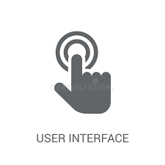**IOT Devices**

**Web User Interface**

1.Book

Tickets





**Passenger QR Code Received Train Ticket**

**Examiner**